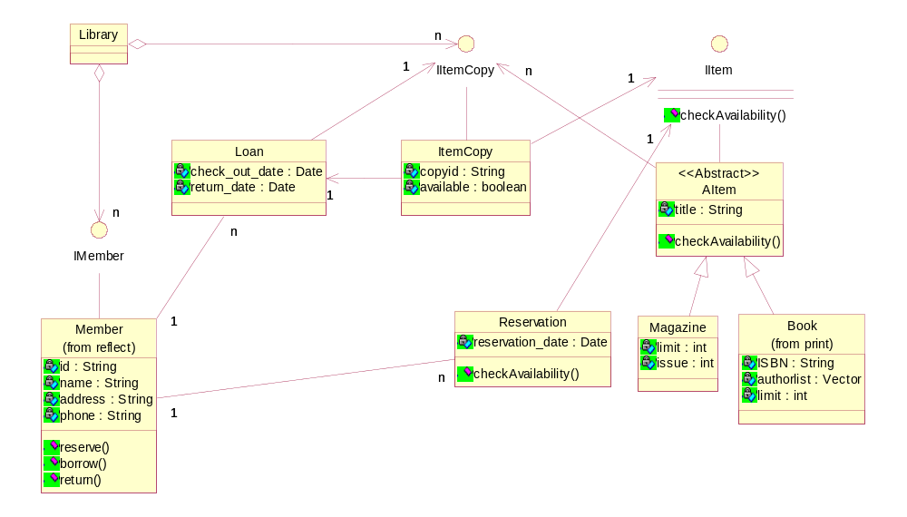

1) IItem i1 = new Book … or new Magazine …
The reference is to the interface, BUT the concrete object is a Book or Magazine

2) Loan has one IItemCopy because it does Not want all of the copies.
This is different from the order tracking system where a Customer
Did Not have a relationship with OrderLine, because the customer Did Want
All of the OrderLines, and got them all through an Order.

